Exercise 14_Webserver

s214417 Lukas Schou

s214413 Christian Cederhorn

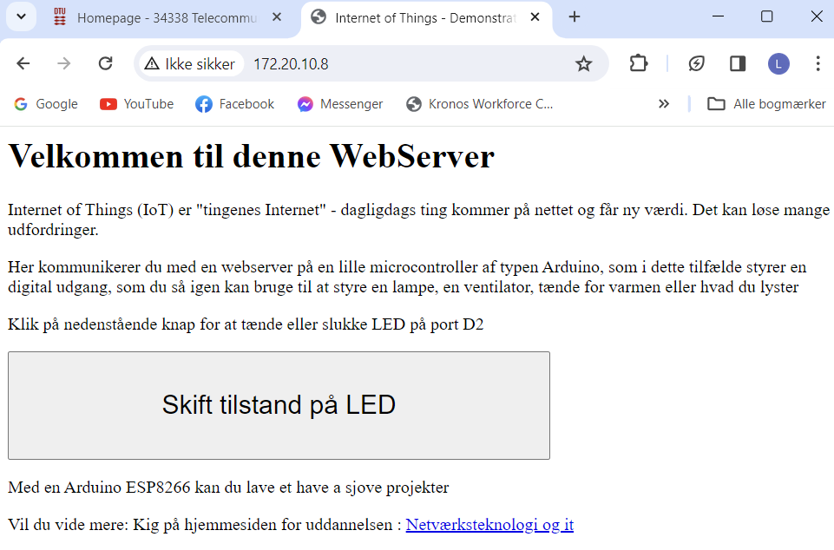

Questions

* 14b: What is a server?

A server is a hardware device or software that manages, stores, and sends information or services to other devices over a network.

* 14a: What is a GET request? And how is it different to a POST request?

A Get request is used to retrieve information from a server where a POST request is used to send data to a server.